**PDA: Student Development**

**Level 8: Student Evidence Checklist**

Ref: I:T 5

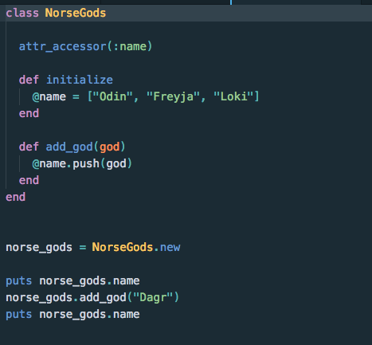

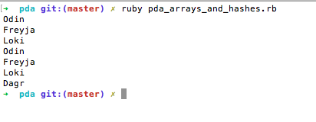

Ref: I:T 6

